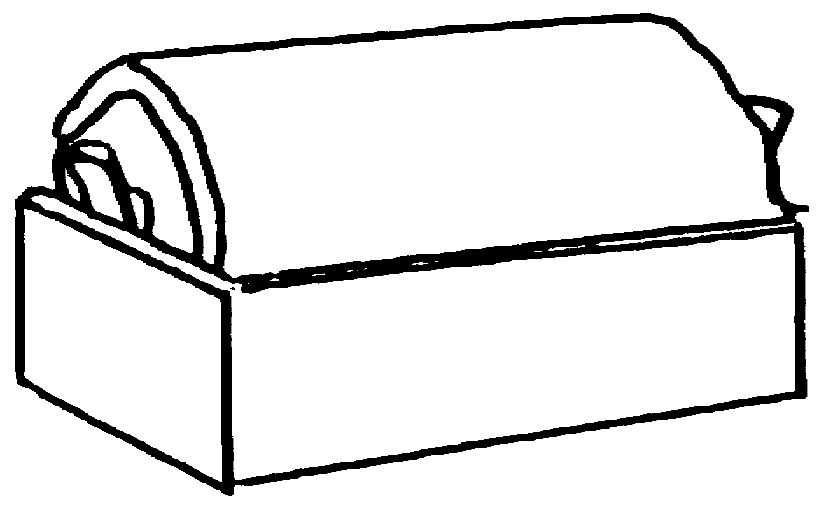
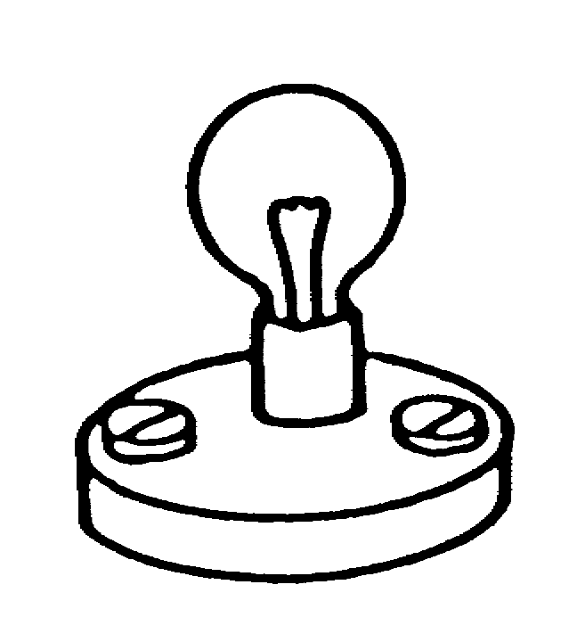
39
bulb 1
bulb 2

In this circuit the two bulbs are
identical. Both are lit.

bulb 2
Sam then removes bulb 1.

(a) What will happen to bulb 2?

Tick ONE box ():

❑ | Bulb 2 will get brighter.
❑ | Bulb 2 will stay the same brightness.
❑ | Bulb 2 will get dimmer.
❑ | Bulb 2 will go out.

(b) How would you explain this?

Tick ONE box ():

❑ | The break comes after bulb 2, so it doesn’t affect it.
❑ | The circuit is broken so there is no current anywhere.
❑ | Bulb 2 gets all the current instead of having to share it.

